

Specification Design report

Former companion



**Specification and Design Report**

**Student’s Name:**

**Students Number:**

**Student’s Email Address:**

**Project Title: Farmer Companion**

**DA Class ID:**

**Name of DA:**

**Name of GDI:**

**Name of SSM:**

**The Specification:**

**Background:**

The current status of agricultural sector that includes populated information, rapid technological improvements, governmental intervention, and influence of professionals has contributed to a dynamic way of disseminating agricultural information. The way agricultural information is gathered and disseminated across all global regions have taken a dynamic change due to the rapid growth and development of information technology as well as increase of computer-related devices. It is notable that the way agricultural information is delivered or acted upon differs with individual circumstances, production region, or enterprise mix, as there are no streamlined standards that control farming activities.

**Project Context:**

This product is designed to automate the farming industry. It is something the farming industry is craving for. Within few simple steps, it will unable every small or big farming industry to increase productivity and decrease cost. Keeping them aware of the modern tools and technologies, will help them analyse their farm in a better way. Moreover, interacting with farmers, giving them the cost effective solutions to their problems is the competitive edge of this software product. It will automate the most time investing work i.e. monitoring of crops and land and will guide the easiest way outs to carry operations.

**Problem Statement:**

It refers to the collection of relevant data from a vast number of sources and translating it into actionable information so as to insightfully solve problems at large scale and speed thereby improving business processes. The new era of information is because of the immense competition in the business world forcing businesses to try and take never-ending precautions to ensure that they do not slip up. According to projections by experts, the population of the world will hit over nine billion by 1950 and to sustain that population will require food production to increase by sixty percent. The department of agricultural have been trying hard to standardize and providing modern information about farming methods but it has not embarked on any innovative ideas, as though in this project. Because information brought this many changes in the business world, in farming, the changes will be a sight. Despite having the innovating ideas to use farming applications, the agricultural stakeholders in Atlantic Canada have not embraced the power of technologies because the solutions have been poorly used in most private farms.

**Product Advantages:**

* Gather Data from different sources (Survey, Data sourcing)
* Give Recommendations to farmer based on data
* Intuitive
* Cost reduction
* Increase Productivity
* Increase Food Production

**Target Audience:**

Farming industry

**Ethical considerations:**

Our initial stage requires responses from farmers. We can get the initial data from the surveys by asking different questions from the farmers. The Techniques they used to improve the productivity and the techniques they used to overcome the disease of their crops. After asking the different questions related to the problem they are facing, industry and area. We will recommend the best practise to the farmer to improve the production and that will be helpful in farming.

**Data Gathering:**

The project work will involve gathering a lot of data like:

* Currently using processes
* We can get data from surveys
* Takes feedback from formers
* Takes input former different farm industries
* Process the Information and Recommends the best solutions

**Tools/ Software to be used:**

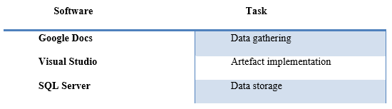

**Project Flow:**

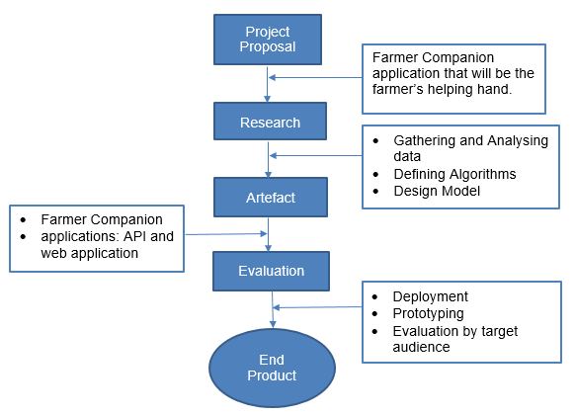

**Literature Survey/Review:**

A lot of work has been done previously in this regard. Highlighting few of them:

**Digital Farming:**

In today’s modern era, data is considered to be the integral part. Whatever organization or industry we take, most important asset is the “data”. Thus, to manage it is also a big task. With advancement; big data analytics came into existence and is holding over every major other sector of the world. Whether it is an institution or a Google deep mind, big data analytics is everywhere. Foreseeing the advantages, scholars and writers thought of initializing it in farming industry. They were sure that “digital farm” will be a sight to watch.

**Need of big data in Agriculture:**

We should find ways to produce and distribute more food because it has been estimated that there will be an increase in population and it will result in about 9 billion people by 2025. The fact that agriculture covers about 40% of the earth’s surface is challenging. During production a lot of food is lost and wasted which affect the economy by $940 billion. All of these assumptions and estimations tell us there is a need of data efficiency in agriculture and the food industries.

**Cropio:**

The operations and activities associated with agriculture, user planning, remote monitoring of agricultural land, real time crop conditions and problem areas updates, analysing vegetation levels, weather forecasts, market overview are all carried out by Cropio which is a satellite based management system.

**Easy Farm**:

The income and expenses record, input transactions, inventories update, creation of up to date balance sheet are all done and tracked using Easy Farms which has chart of accounts synchronized with agriculture industry and provides great selection of reports. Making budgets, tracking family expenses and how it can be reduced can be done with the help of Easy Farm software. There are many pros and cons of this software. This software is not cloud based but it cannot be considered as a disadvantage because it provides us with backup facility due to which or important data is not lost even if we exit the program, or our system is shut down accidentally. Other benefits include no fee for using this software, saves the system from hacking. Easy farm provide user friendly interface it provides real time transaction update by providing with a deposit slip. It provides with technical assistance from the people who are familiar with agriculture and English language whenever you think you are stuck at some point. You are just a call away.

**Tamero.com:**

The software provides you with device friendly interface, manages your farm by providing real time reports on cell phones, real time update of information on all devices, provides visual environment to manage crops. Tracking and recording history, customized weather forecast for your location. All these activities are carried out using one software, which is Tambero, termed as the future of farming.

**Literature Survey References:**

[1.] Galt, RE 2013, ‘The Moral Economy Is a Double-edged Sword’, Economy Geography, 89, pp. 341-365.

[2.] <https://www.talend.com/blog/2018/03/19/how-big-data-is-growing-agriculture/>

[3.] https://www.capterra.com/p/133659/Cropio/

[4.] https://www.capterra.com/p/16509/EasyFarm/

[5.] .https://www.tambero.com/farm-management-en

**The Design**

The software aims at providing an efficient interface to the user for managing their farm activities, it will provide user various options to increase their productivity. It will play a role of a

* Farmer
* Advisor
* Processor
* Problem Solver

The respective farm will be continuously monitored against several principles and natural calamities. The design is such that the user does not have to manually keep check and balance of farm activities, the Software does it for the user.

**Use Case Diagram:**

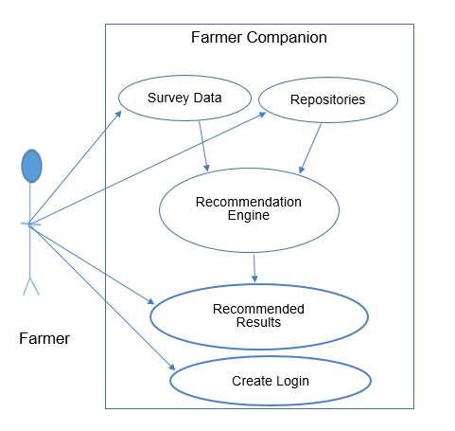

**Software, in a picture:**

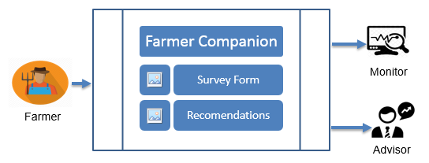

**Architectural Design:**

State of the art techniques were formulated to ensure prototypic implementations are achieved for ensuring modern and flexible management of the farms. The Service-Oriented conceptual architecture that includes various parties such as consumers, brokers, and providers, as illustrated below.

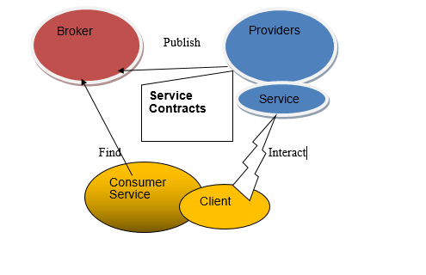

**Description:**

**User End:**

Users either asks for support from the system or gives input (enter data) that will be stored in the database.

**System End:**

Action will be taken against user query input. System will search for possible solutions in different departments like (production unit department, resources department, climate department etc. According output will be generated. It will be in form of solutions, series of steps which a user is supposed to follow.

**Flowchart:**

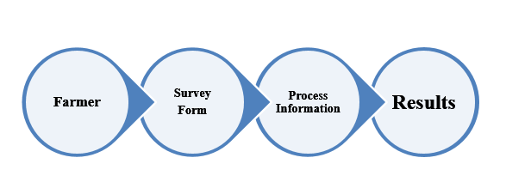

**Actor:**

Farmer will be the main actor of this software system.

**Framer (User):**

* User can create account.
* Login
* Fill the Survey form
* The user will recommended with best solution

**User Description:**

|  |  |
| --- | --- |
| **Use Case Name** | **Description** |
| **Login** | This operation allows farmer to access the site with authentic id. |
| **Manage Account** | This operation allows farmer to control his/her account like change password etc. |
| **Add Data** | This operation allows farmer to add data that will be processed according by the system.  For example: User will enter his location/industry details/appropriate figures |
| **Delete Data** | This operation allows farmer to delete specific entry. |
| **Update Data** | This operation allows farmer to update specific entry. Like he can change his location or want to change current profit figures etc. |
| **Add Query** | This operation allows farmer to ask for concerned problem against which he wants the solution. |
| **Ask for Solution** | After entering concerned problem, system will ask user if he wants a solution to it, user will click on it and appropriate series of steps will be displayed on the screen. |

**Deliverables**

**Deliverable 1:**

* Project Proposal
* Project Overview

First deliverable will involve a brief introduction about our system. What it is? How it works?

**Deliverable 2:**

* SRS.tc.
* Literature Survey Report
* Analysis

Major deliverable of this phase will be Software Requirement Specification document (SRS) that will be generated after requirement gathering from our target user. It will be the extended brief version the proposal.

**Deliverable 3:**

* SDR

Software Design Report will be our third deliverable. After SRS, we will be focusing on the flow of our system. It will include tentative designing of interfaces, activity diagrams

**Deliverable 4:**

* System Prototype

After SDR, we will be coming towards the actual coding section. I.e. implementation. This will generate a dummy mode that will be shown to our end user. This will be checked against SRS and will require user feedback.

**Deliverable 5:**

* Complete system documentation including system implementation.

It will be the final report containing all deliverables report. It will include everything that is even a bit related to our software. From the point we started (planning) till how it looks in real, it will include everything. Moreover, depending on the time, we will be adding a user guide that will help narrative user to access it easily.

**Project Plan**

|  |  |  |  |  |
| --- | --- | --- | --- | --- |
| Task | Assigned To | Start | End | Days |
| Proposal Approval | Elad |  | 1/9/2018 |  |
| Choosing a DA | Elad |  | -- |  |
| Data Collection | Elad |  | -- |  |
| Project Specification and Design | Elad |  |  |  |
| Implementation | Elad |  |  |  |
| QA | DA |  |  |  |
| Evaluation | Elad |  |  |  |
| Write Up | Elad |  |  |  |